📘 NNFX Trade Entry Strategy & Algorithm
Friday, April 10, 2026
1:05 AM

📘 NNFX Trading System
Algorithm Documentation

1. System Overview
The No Nonsense Forex is a rule-based, indicator-driven trading framework designed to:
- Eliminate discretionary decisions
- Standardize trade execution
- Use volatility-based risk management
- Operate on confirmed candle closes

🧩 2. System Components
📊 Indicators
Component | Purpose
ATR | Volatility measurement (SL, TP, distance rules)
Baseline | Defines trend direction
C1 (Main Confirmation) | Primary entry signal
C2 (Secondary Confirmation) | Signal validation
V1 (Volume/Volatility) | Market strength filter
Exit Indicator | Trade exit signal
(Optional) Continuation Indicator | Used for trend continuation entries

⚙️ 3. Core Trading Principles
3.1 Candle-Based Execution
- All decisions are made only at candle close
- Prevents noise and false signals

3.2 Rule-Based Validation System
The algorithm enforces three critical filters:
Filter Type | Rule
Location | Price must be near baseline (R1: ≤ 1×ATR)
Timing | Signal must be recent (R3: ≤ 7 candles)
Synchronization | Indicators must align within 1 candle

3.3 Multi-Path Entry System
The system evaluates four distinct entry strategies:
- Standard Entry
- Baseline Cross Entry
- Pullback Entry
- Continuation Entry
1. System Overview
The No Nonsense Forex is a rule-based, indicator-driven trading framework designed to:
- Eliminate discretionary decisions
- Standardize trade execution
- Use volatility-based risk management
- Operate on confirmed candle closes

🧩 2. System Components
📊 Indicators
Component | Purpose
ATR | Volatility measurement (SL, TP, distance rules)
Baseline | Defines trend direction
C1 (Main Confirmation) | Primary entry signal
C2 (Secondary Confirmation) | Signal validation
V1 (Volume/Volatility) | Market strength filter
Exit Indicator | Trade exit signal
(Optional) Continuation Indicator | Used for trend continuation entries

⚙️ 3. Core Trading Principles
3.1 Candle-Based Execution
- All decisions are made only at candle close
- Prevents noise and false signals

3.2 Rule-Based Validation System
The algorithm enforces three critical filters:
Filter Type | Rule
Location | Price must be near baseline (R1: ≤ 1×ATR)
Timing | Signal must be recent (R3: ≤ 7 candles)
Synchronization | Indicators must align within 1 candle

3.3 Multi-Path Entry System
The system evaluates four distinct entry strategies:
- Standard Entry
- Baseline Cross Entry
- Pullback Entry
- Continuation Entry

🔄 4. Entry Decision Flow
📊 High-Level Flow

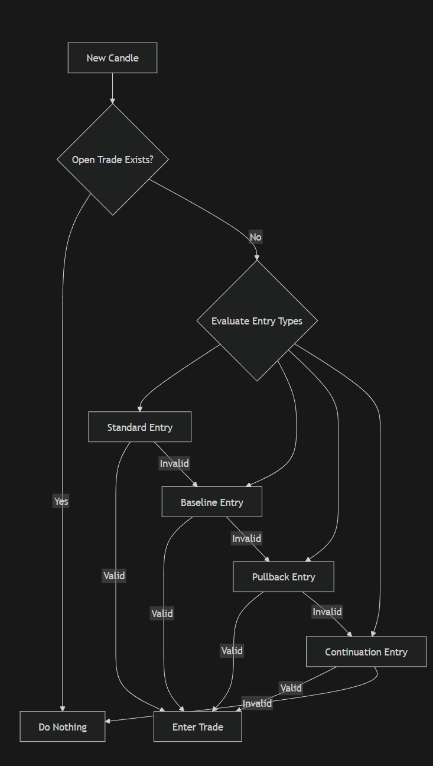

Code </> Mermaid
flowchart TD
A[New Candle] --> B{Open Trade Exists?}
B -->|Yes| Z[Do Nothing]
B -->|No| C{Evaluate Entry Types}

C --> D[Standard Entry]
C --> E[Baseline Entry]
C --> F[Pullback Entry]
C --> G[Continuation Entry]

D -->|Valid| H[Enter Trade]
E -->|Valid| H
F -->|Valid| H
G -->|Valid| H

D -->|Invalid| E
E -->|Invalid| F
F -->|Invalid| G

📈 5. Entry Strategies

✅ 5.1 Standard Entry
Trigger: C1 signal
Conditions:
- Baseline agrees with direction
- Price within 1×ATR of baseline (R1)
- C2 confirms
- Volume confirms

🔄 5.2 Baseline Cross Entry
Trigger: Price crosses baseline
Conditions:
- C1 agrees
- Price within 1×ATR (R1)
- C2 confirms
- Volume confirms
- C1 signal occurred within 7 candles (R3: Bridge Too Far)

🔁 5.3 Pullback Entry
Trigger: Trend already established
Phase 1:
- Baseline gives signal
- Price moves beyond 1×ATR
Phase 2 (Next Candle):
- Price returns within 1×ATR
- All indicators align

🚀 5.4 Continuation Entry
Trigger: Existing trend continuation
Conditions:
- Prior entry signal exists
- Baseline has not been crossed since
- Continuation signal (or C1) appears
- C1, Baseline, and C2 agree

📏 6. Rule Definitions

📐 R1 — Distance Rule
- Price must be within 1×ATR of baseline
- Prevents late entries

🌉 R3 — Bridge Too Far Rule
- C1 signal must be ≤ 7 candles old
- Prevents outdated signals

⏱️ 1 Candle Rule
- All confirmations must align within 1 candle
- Otherwise, signal is invalid

💰 7. Trade Execution & Risk Management

7.1 Position Structure
Each trade consists of two positions:
Order | Risk | SL | TP
Order #1 | 1% | 1.5×ATR | 1×ATR
Order #2 | 1% | 1.5×ATR | No TP (runner)

7.2 Trade Management Flow

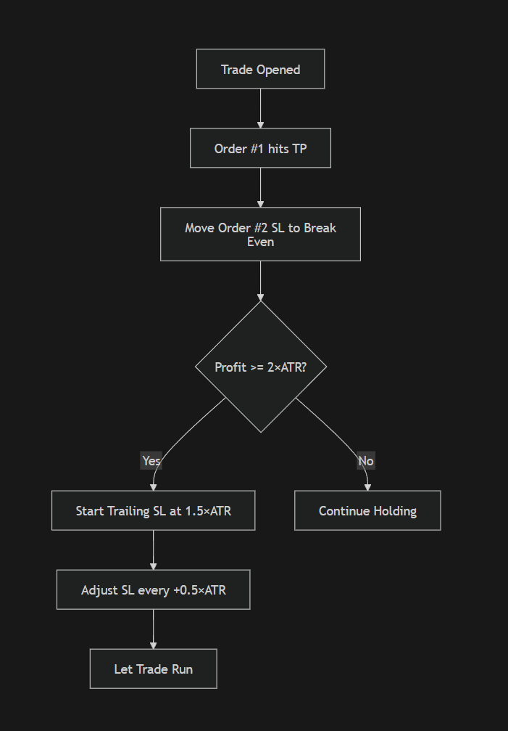

Code </> Mermaid
flowchart TD
A[Trade Opened] --> B[Order #1 hits TP]
B --> C[Move Order #2 SL to Break Even]
C --> D{Profit >= 2×ATR?}
D -->|Yes| E[Start Trailing SL at 1.5×ATR]
D -->|No| F[Continue Holding]

E --> G[Adjust SL every +0.5×ATR]
G --> H[Let Trade Run]

🚪 8. Exit Strategy
A trade is closed when any of the following occurs:

Exit Conditions
- Exit indicator gives signal
- Price crosses baseline
- C1 gives opposite signal

📊 Exit Flow

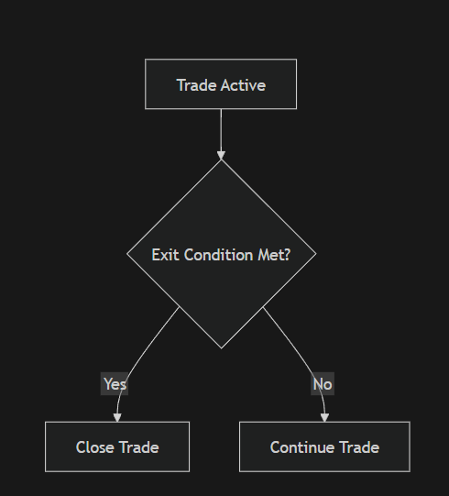

Code </> Mermaid
flowchart TD
A[Trade Active] --> B{Exit Condition Met?}
B -->|Yes| C[Close Trade]
B -->|No| D[Continue Trade]

🧠 9. System Behavior Summary

✔️ Strengths
- Fully systematic (ideal for automation)
- Volatility-adaptive (ATR-based)
- Multi-entry flexibility
- Strong trend-following logic

⚠️ Constraints
- Requires strict rule adherence
- Performance depends on indicator selection
- Needs extensive backtesting (baseline + C1 combinations)

🏗️ 10. Conceptual UML (Architecture View)

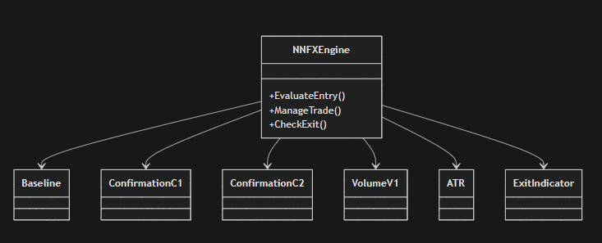

Code </> Mermaid
classDiagram
class NNFXEngine {
+EvaluateEntry()
+ManageTrade()
+CheckExit()
}

class Baseline
class ConfirmationC1
class ConfirmationC2
class VolumeV1
class ATR
class ExitIndicator

NNFXEngine --> Baseline
NNFXEngine --> ConfirmationC1
NNFXEngine --> ConfirmationC2
NNFXEngine --> VolumeV1
NNFXEngine --> ATR
NNFXEngine --> ExitIndicator

🎯 11. Key Takeaways
- NNFX is a decision framework, not a single strategy
- Entry depends on context (4 entry types)
- Success depends heavily on:
  - Indicator selection
  - Strict rule enforcement
  - Proper risk management

🚀 Final Insight (For Your EA Project)
To implement NNFX correctly, your system must:
- Support multiple entry pathways
- Enforce R1 + R3 + 1 Candle Rule
- Maintain state awareness (for continuation trades)
- Separate:
  - Entry logic
  - Trade management
  - Exit logic

